S O U R C E OF L I G H T, G H A N A
P. O. BOX LT 189 LATERBIOKORSHIE - ACCRA, GHANA
P HONE: (Office) +233-302-322908 (Cell) +233-244-641583
EMAIL: ghana@slmin.org; dugbanordt@yahoo.com WEB: slmghana.org
2023 3RD QTR NEWS LETTER
Dearly Beloved Missionary Friends:
BUILDING FOUNDATIONS IN ASHANTI MAMPONG
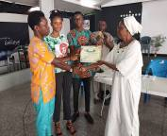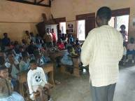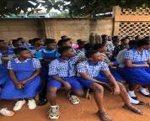
The Ashanti Mampong ADS was registered and certified on 1st July. Pray for the total of 195 Primary and Junior High children studying the MBC lessons from one public school and one private school. There are plans to reach out to more public and private schools as well as churches
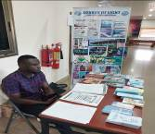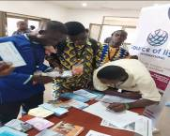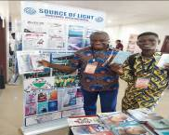
Some participants of the AFRICA STRATEGIC YOUNG PROFESSIONALS SUMMIT GHANA 2023 was hosted
by Pioneers Africa. SLM Ghana mounted a display which was visited by some participants from other countries who were given sample lessons and tracts which they took back to their countries.
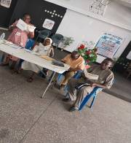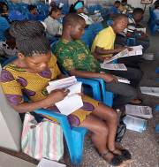
CEF Teacher Training Instructors guiding participants in how to effectively teach the Bible Lessons to prepare
the children towards the 2023 Mailbox Club Rally to be held on Saturday 25th November, 2023 in Accra.
Over 50 participants came from Churches, Schools and Good news Clubs. Associate School Discipleship
School Certificate was presented to new Discipleship Schools registered.
P.T.O.
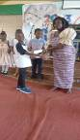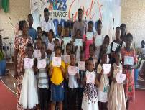
SLM Certificate Presentation was held at Mamprobi Baptist Church in Accra. 1st picture is the Pastor of the Church presenting a certificate to a child. 2nd picture is Mrs. Gifty Sappor presenting certificate to another child
The 3rd picture shows the teacher of the children presenting certificate to another child. I was privilege to preach during the church service on the theme “Rescue The Perishing”.
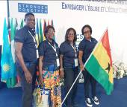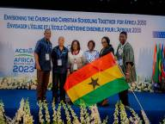
Four delegates from Ghana attended the ACSI Africa Conference held in Kigali, Rwanda. The THEME for the Conference was “Envisioning The Church and Christian Education Together For Africa 2050”. Over 236 delegates from 30 African countries and 7 other countries attended the conference.
PRAISE AND PRATER
- For the voluntary team members God is using in our ADS in Ashanti Mampong. One Public School and One Private School are now active in allowing the children to do the Bible lessons. 123 Children are doing the lessons in the Primary Classes and 72 children in Junior High.
- The only sponsor of our Missions & Job Training Program has renewed her commitment to continue with her sponsorship for another 2 years as God gives her the enablement in spite of old age and movement of apartment challenges she is facing. Please PRAY for her.
- ECA VISION 5 PROJECT: Increase enrollment from 250 to 500, complete 12 classroom block construction which has 6 classroom upstairs remaining and provide new school bus to support the very old one now in use between 2024 and 2028 to mark ECA 25TH ANNIVERSARY.
- Pray for the 94 Needy Children at the ECA School at Tefle need sponsors who can give $35.00 monthly for their Educaton, Health, Care, as well as Job Training.
- 2024 DEPUTATION: Plans going on to visit supporting individuals & churches from April to September.
Pray as I raise funds for air ticket, travels while in the USA as well as upkeep for 6 month.

CONCLUSION:
We are reminded once again that it is ALWAYS through your continued Prayers and Financial Support that OUR HEARTS ARE NOT TROUBLED in the work entrusted into our hands as we “ATTEMPT Great Things For God and EXPECT Great Things From Him”.
Sincerely
Saving Souls & Building Lives
SLM GHANA NATIONAL DIRECTOR

Source of Light Ministries International, 1011 Mission Rd., Madison, GA 30650
PHONE: 706-342-0397 EMAIL: slm@slmin.org WEB: www.slmin.org

